Active Noise Cancellation System for Power Transformer-Development and Validation

Mehwish Batool¹, Hassan Azwar², Aneela Sajjad³

1, State Key Laboratory of Electrical Insulation and Power Equipment
Xi’an Jiatong University, Xi’an, China. P.R.China, 710049
2, Faculty of Computer Science, National University of Science and Technology NUST , Islamabad, Pakistan
3,Comsats Institute of Information Technology, Abbottabad, Pakistan
mehwishbatool63@gmail.com

Abstract

Transformer noise is a silent killer that not only causes hearing loss but also life quality degradation. Unlike the other active noise cancellers developed, the precise ANC model on MATLAB was built and verified through laboratory experiments. The simulation model validity is checked at different locations in acoustical field. The results presented here implies that the model developed here has the capability of reducing the noise efficiently.

Keywords-Active noise canceller; simulation model; MATLAB

I. Introduction

The magnetostriction of Silicon steel sheets instigates the stator core vibration and produces the vociferous transformer. 50 Hz operational frequency transformer first harmonic produce double sound that is 100 Hz. The noise spectrum of 110 kV power transformer lies below 2000 Hz range [1]. The core geometry, core material , flux density and the excitation voltage waveform effects the frequency and the magnitude components of the transformer core noise levels. The electromagnetic forces emanating due to leakage current fields are proportional to load current square. The frequency of load noise is twice the power frequency. The noise power of the winding is just in few dB less than of core. The hearing stultification is eventuated through the continuous revelation to noise. Various chronic and neural disorders may results through the exposure to transformer noise.
The noise problem could be dealt through two ways, the passive and the active noise control ways. The bulky sound proofing materials, barriers, closets and acoustic insulation for noise cancellation passively makes the system quite unpractical. Hence, acoustics, signal processing and mechanics combination quite comprehendendly deals with the practical potential application of active noise control system. Cost reduction alongwith mass and intensity and betterment in noise removal are the consequences of ANC [2]. If constructive interference occurs then amplitude of resultant is doubled otherwise for destructive interference the amplitude becomes close to zero. The opposite phased but same magnitude wave is produced through ANC system [3].
There are many methods for active noise cancellation are present in literature for power transformer in the manner of waveform synthesis method [4], notch filter [5], and particular algorithm [6]. The input signal is needed in these approaches obtained through different ways [7]. The active noise cancellation study based on FXLMS was done in [8] for multiple-sound levels. The ANC system based on MATLAB/Simulink for power transformer was developed “in press” [9].
The main objective of the research is the experimental validation of an ANC system developed in [9] for power transformer. Active noise canceller implementation in real time compised of active noise profiling through controller and the measurement setup through virtual microphone. The simulations and the experimental outcomes shows the active noise canceller feasibility in utilization for power transformer.
The paper is arranged as: Section II discusses the structure of active noise canceller. The design deliberation and the devices for sensing the path are described. Section III is about the modeling of an active noise cancellation system. Section IV gives the simulation process. The detailed adaptive algorithm considered for modeling the active noise canceller utilizing finite impulse response filter is altercated. In section V the experimental setup and the results are summarised. Conclusions are made in section VI.

II. ANC Structure

The electronic tranducers and the acoustic amalgamation makes an active noise canceller structure. They interacts with the primary noise field. The reference sensor , error sensor and the anti noise source makes the ANC system and the controller is meant for the algorithm. The system outline is given in Fig. 1.
The components of ANC system are given below:

A. Reference Sensor

A reference sensor is used to provide a measurement called as reference signal of the menacing noise before it reaches the controller. If the sensor is placed upstream of the controller then it performs the required priori noise sampling.

B. Control System

The control system is culpable for catching the reference

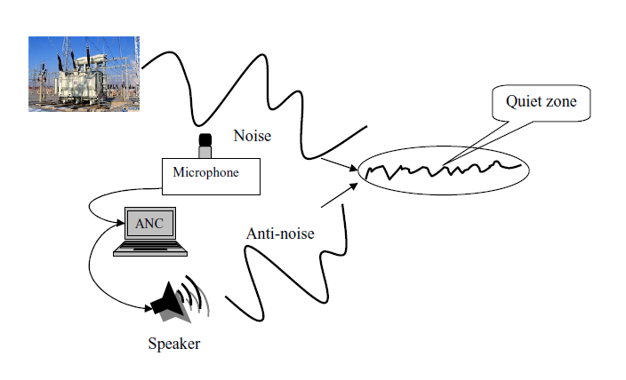

- Acoustic Noise Scenario
signal measurement of noise impending and calculating the value that needs to be cancelled out. The system ought to be fast
responsive in case the undesired noise arrives.

C. Control Source

The control source is used to produce the anti noise (cancelling) sound field . The anti noise source is speaker.

D. Error Sensor

The error sensor is used for sampling the noise that actually left the cancellation performed. This is named as error signal as it identifies that how much the controller is in error when it derives the cancellation waveform. The perfect calculation results in no error signal as all the undesired noise is cancelled. have it.

III. Simulations

The estimation of ANC system in actual noise field effects the noise estimation that is far from the location of sensors. Hence , the objective was to valuate the noise location different from the error sensor position. The sound pressure field is the sum of primary and the secondary noise that are given in (1).
(1)
where, s is for secondary sound field and p is for primary. The typical linearity assumption is valid for the normal situations sound pressure level. The core component of this system is the controller that put together the transducers to generate secondary sound field.
If the controller is responding to the changes in system under consideration then called as adaptive. This filter is designed in a way that matches the reference signal to the primary noise in a preferred way. Mostly, the FIR (finite impulse response) filter is used. The FIR coefficients calculation of optimal values to stationery noise utilizing the cross correlation among desired and the reference signal is possible to be done. The error signals’ mean square error is minimized through the optimized coefficients. Practically, the non stationery noise is impossible to calculate through the arriving signals correlation properties. The calculation is constant so the optimal filter coefficients computational burden is pricey. The adaptive filter coefficients make an l+1 dimension mean square error or performance façade. Here, l is the filter coefficients number. The optimized coefficient values of filter are iteratively looked for the performance surface gradient. The update method of filter coefficient is through the equation having n as the iteration.
(2)
The iteration index is given by n, ∇ξ (n) is the gradient of the MSE and the convergence factor is given by. The mean square error is defined as:
(3)
Here, desired signal is d(n) and the reference signal is x(n). The total to the previous coefficients of filters and the adaptive filter estimate of gradient through the tap weight w is given by equation below where l is the tap index of filter [8].
(4)
The algorithm convergence is possible with the factor of convergence. The larger the convergence factor the less stable will be the adaptive process. The limits of indication for convergence will be
(5)
The L is the filter length. The upper limit of convergence factor is 0.005 to 0.05. The transfer function determination and the measurement ability through the secondary input to the error output sensor could be done then is able to imitate the secondary source input with controller model. The primary noise assumption is also included.
The equation get when the sound pressure sum is set at zero that is defined in (1) then can be given by the following
(6)
Here x_{e} is the place where error sensor is present. The convolution of input secondary source impulse response to the error sensor gives the secondary source signal in equation below:
(7)
Here y(t) is input signal to secondary source and h_{e} is secondary path impulse response. The de convolution of input signal gives an estimate. After taking F [.] Fourier transform for both sides of above equation the result is
(8)
The input signal Fourier transform is divided to the left side and after inverse Fourier F₋₁[] transform the equation is:
(9)
The R.H.S of (9) secondary noise is substituted and the impulse response Fourier transform is H_{e}(ω). The secondary noise estimate at location other than error sensor can be calculated after having knowledge of input signal. It is clear from (9) that when the impulse response Fourier transform tend to zero than in ω frequencies y(t) becomes infinite. The non limitation of input signal level or the attenuation capacity of noise results in idealized situation according to the equation.
The set value consideration of zero totality of noise do not accounts for either the noise is tonal or broadband. If more transducers or sensors are placed than calculated conditions become complicated and attenuation in noise gets limited to a
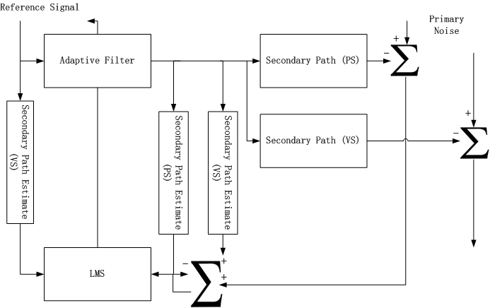

- Simulation Model framework
certain value. The below equation gives the estimation and attenuation capacity of active noise control system performance via reference and noise signal coherence.
(10)
The maximal noise attenuation could be achieved and calculated in decibels as frequency function. The function of coherence γ 2 ( f ) is among 0 and 1. The simulation model accurate precision is fair for a control system development in that outlook. The basic modeling blocks of active noise controller design are given in Fig. 2.

The parameters, algorithms, control and their respective delays have consequence on secondary noise. In addition to this the noise dynamic characteristics also encompasses the secondary noise and the controller design could not be counted on through a simple equation.

V. ANC System Modelling

The modeling of an active noise canceller is separately discussed through the two sound fields primary(noise source) and the secondary (anti noise) fields.

A. Primary Noise

The start of noise through the vibrating bodies sometimes these noise sources are the point sources and mostly the need is to transfer that noise to another body or enclosed space. The modeling of primary noise is through the analytical functions like the rigid wall box with monopole source or the region that is field free. The detailed approach is instanced in [10] and [11]. The supplement of every element in reciprocity to the sound field is graspable to the analytic approach.
The origin of noise and the discerning of noise cravings are advantageous for analytic methods. When the enclosing structures become realistic then the exceptions arose. Many exceptions arose. The primary noise field can be measured . The recording of the noise in the real time system should be done when the signals are kept synchronized. Table I gives the comparison of different methods used for primary noise modelling.
TABLE I
PRIMARY NOISE MODELING METHODS COMPARISON
Attributes | Analytic Methods | Computational Model | Measurement
Low Cost | Good | Fair | Poor
Accuracy | Fair | Fair/Good | Good
Generalization  General details | Poor  Good | Fair/Good  Fair | Poor  Poor
Consideration of details | Poor | Fair | Good
There are locations where the signals are captured. The design phase whole product is done through the numerical methods for primary noise field.

B. Secondary Noise

The secondary noise field modelling faces the basic challenges. The secondary field simulation can be done as soon as the secondary source inputs are identified. The approximation of control system well-nigh is a simple model. If the primary noise is stagnant and is only one secondary source then the error signal is an idyllic control system. The dominant secondary field simulation could not be thru and is recursive if the noise primary information is not given. The primary noise assumption must be included. The transfer function fortitude and the measurement capability through the secondary input to the error output sensor was done then imitate the secondary source input with controller model.

IV. Experimental Results

The setup was established in a middle sized room that is hard walled having dimensions 2.9 m by 5.6 m by 4.8 m. The space left was bounded around the enclosure till 1.6 m width with shelves that was 2.8 m long and 2.0 m high. In this measuring sample the simulation algorithm which was explained in previous section was utilised and the active noise profiling mass was took out of the controller.
The basic factor that needs to be considered for effective noise cancellation is adjusting the position of speakers.
Fig. 3 gives the detailed block diagram of the first measurement setup with MATLAB as control system for generating the anti-noise signal. Fig. 4 gives the experimental setup of the above given block diagram. The acoustical signal is sensed through the sensor that is microphone of the cell phone. The signal is produced through the noise source that is speaker and fed in the ANC system which run the noise cancellation algorithm in MATLAB. Hence, produces the anti noise signal which propagates through the anti noise source (speaker). These signals are mixed in air as medium producing a quiet zone.
Fig. 4 shows that the noise and antinoise speakers are facing each other. They are separated through a measured distance in accordance with the frequency choosed. The parameters like frequency, wavelength, background noise and the ANC system results before and after cancellation are given in the Table II.

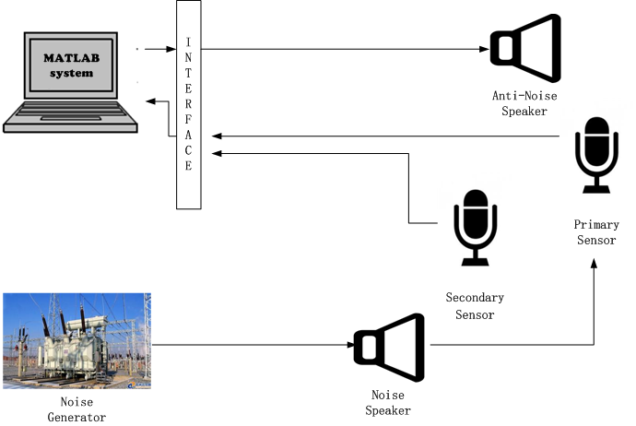

- Experimental Setup (Block Diagram)
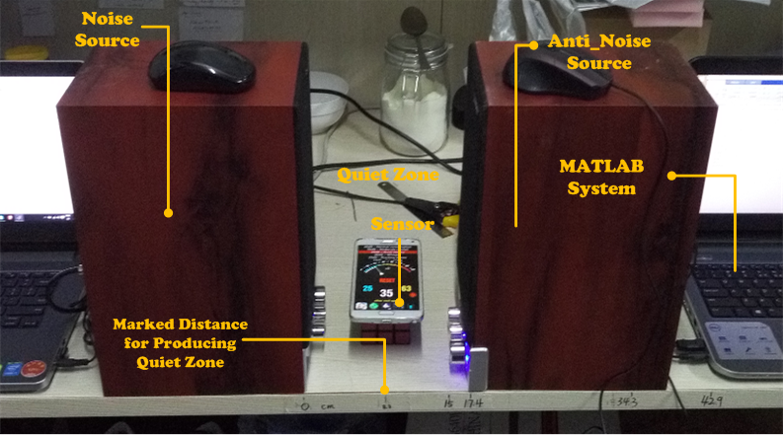

- Experimental Setup (Hardware)
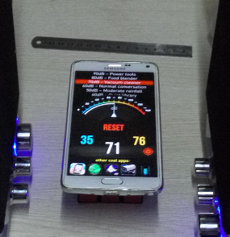
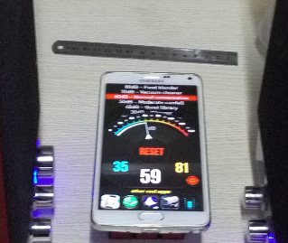

- Results before and after noise cancellation
TABLE II
NOISE CANCELLATION RESULTS AT VARIOUS FREQUENCIES
Frequency  (Hz) | Distance between speakers  (cm) | Before Noise Cancellation  (dB) | After Noise Cancellation  (dB)
2000 | 17.4 | 71 | 59
1000 | 34.3 | 80 | 52
800 | 42.9 | 75 | 65

The experimental results shows that when the maximum noise cancellation that is 28 dB is achieved when the noise frequency is 1000 Hz. The places where background noise was affecting the noise canceller then the exact results as through the simulation process was not achieved. Therefore, at those sensor points the noise cancellation was less than 10 dB. These sensor locations are not included in the result tabulation. Henceforth, the active noise canceller developed in simulation model devised is verified and will be utilized in the transformer locale constraints.

VI. Conclusion

The research verifies the transformer noise reduction model through experiments that are performed in laboratory. The simulation model was developed and simulated in MATLAB/Simulink. The system that is developed guarentees the upgradation of active noise canceller. The product study derives valuable impending on the algorithm things. The noise canceller mechanism is generated through the MATLAB simulation dais. The optimized locations of placing the sensors, noise and anti noise sources are studied and the results are derived from the place having the flattest response in magnitude. The algorithm is tested experimentally imitating the real time setup utilizing the speakers and sensors.
In future, the same algorithm will be verified in a transformer field with real time setup of multiple-sound sources like speakers and sensors that ought to be microphones and the total noise cancellation will be checked at each sensor location at different times. Active noise cancellation study created on FXLMS algorithm would also be directed in potential to progress model that turns out effective when useful to the field.

References

- D. P. Das, D. J. Moreau, and B. S. Cazzolato, “Active control of transformer noise by using power line signal as reference,” IEEE 8th Conference on Industrial Electronics and Applications, ICIEA 2013 , pp. 953-956.
- Sen M. Kuo, Sohini Mitra, and Woon-Seng Gan, “Active noise control system for headphone application,” IEEE trans. on control systems technology, vol. 14, pp. 331-335, May 2006.
- Cheng-Yuan Chang and Sheng-Ting Li, “Active noise control in headset by using low cost microcontroller,” IEEE trans. on industrial electronics, vol. 58, pp. 1936-1942, May 2011.
- G.B.B. Chaplin, R. A. Smith, “Waveform synthesis — the Essex solution to repetitive noise and vibration”, Proc. of Inter-noise, pp.399–402, 1983.
- E.Ziegler, Jr., Selective active cancellation system for repetitive phenomena, U.S.Patent 4 878 188,1989.
- X. Qiu, C. H. Hansen, “An algorithm for active control of transformer noise with on-line cancellation path modeling based on the perturbation method,” Journal of Sound and Vibration, Vol. 240, No.4, pp. 647–665, March 2001.
- S. M. Kuo, D. R. Morgan, Active Noise Control Systems: Algorithms and DSP Implementations. NewYork: Wiley, 1996.
- Miskiewicz A. and Letowski T. “Psychoacoustics in the Automotive Industry,” Acta Acustica united with Acustica, vol. 85, no. 5, pp. 646649, September 1999.
- Batool M., Chen Yu and et. al, “Design and Simulation using Matlab/Simulink on Active Noise Control System for Power Transformer”, in press.
- Morse P.M. and Ingard K.U, Theoretical Acoustics. New York: McGrawHill, Inc. 1968
- Fahy F., Sound And Structural Vibration: Radiation, Transmission and Response. London: Academic Press Inc. 1985.

